**Abstract – 200 words**

**Motivation for the project**

**Why developing web based application**

**Flexibility**

**Keywords: web application development**

**The method for achieving this aim is creating a web based application running on local host which can be used to pull out data and generate reports in PDF format. This application enables users to obtain KPI indicators automatically and generate graphs for further analysis. Through the development of this application individuals would now be able to easily and quickly generate reports and deliver it to their customers and suppliers further their understanding of business performance.**

**Introduction**

**It is very crucial that know your business better. At the same time let your customers see your performance and improvement so that can boost the confidence of your clients and win a stable and long term business relationship. That is called business intelligence.**

**The report shows four value driver areas such as financial value, productivity, risk and trust. clarify general business objectives and corresponding performance metrics and indicators. define achievable targets and use the tools to inform the decision-making processes.**

**KPI indicators are essential and important for users and their clients to know the business better. While time spend on generating such report should not take long. Efficient way of Benefit from technology automation let the application helps to do the repetitive work for you.**

**KPI dash board can offer users an intuitive way to review the business performance and even could help to do an accurate and practical projection for the company.**

**Background**

**Looking for an efficient and automated solution to generate monthly, quarterly or annual report based on user’s choice in shorter time. The report would show required KPI indicators and performances of related hauliers.**

**The Problem**

**Manual organizing the data. Since all the documents come from different countries and they have not yet unified the reporting language, this problem cannot be solved at this stage.**

**format**

**Existing Solutions**

**Microsoft VBA creating macros to locate the data and generating graphs. But with macros the excel will experience serval crushes.**

**Requirement:**

**Create a report template with same format of current reporting format that made with excel.**

**Reduce time of creating the report. Analysts from Yusen now need 2 to 4 days to generate the report.**

**Generate report by customize time span easily and flexibly for instance user can generate monthly, quarter, annual report or other time periods they want.**

**Clients want to have a click view section that they can hover to see over on the district map that shows some data of different area of one particular market.**

**+邮件内容**

**Why this method – +表格对比**

**System is updating.**

**Click view in the future**

**More flexible and much easier to generate the report for instance choose a random time span, different hauliers and the performance of hauliers.**

**Suggestion**

**unify the form of data.**

**Aim and Objectives**

**Provide a solution to the business analysts of Yusen logistics that help them to efficiently and accurately generate straightforward reports in shorter amount of time and show the business performance by visualise main KPI indicators for their customers and suppliers.**

**My solution**

**Initial idea**

**Creating a desktop application automatically pull out the certain data that match user’s requirement. Using python as the programming language with assists from other open source python library like pandas for data manipulation and matplotlib for visualization.**

**Product: web application wrote by python language built with flask web framework that works on local host. No internet required secure the data. The application gets HTTP requests which is users’ input in this case, and dispatch code that generates HTML which is rending the customize html template through the flask framework, and creates an HTTP response with that content in this web application is to write the response to a csv file then save it locally.**

**Design**

**Read the original report**

**Get to know the format for the report.**

**It requires to show key highlights of current month, including MMW performances of different hauliers, performances of IMC in different markets along with procurement and quality and those makes the first part of the report.**

**In second part of the report, line chart will show planning performance of all the linehauls through 12 months until current month. And a table will be shown to present the 12 KPI indicators of hauliers separately from current month. Also the report will present the reasons of late arrivals, dispatches and late 1st hub arrivals, time of late arrivals/dispatches by either bar graph or line chart. Then the trending of arrivals, dispatch and 1st hub arrivals of different hauliers will be presented by different line charts. At the end of this part, 3 lines charts will be presented to show the difference between planned and actual vehicles they used, the average LFF per haulier and average pallets they used during the transportation.**

**In the third part of this business report, it focuses on IMC’s performances of different markets. It will compare IMCs’ number of outbound deliveries, number of handling units, total weight, number of returns, number of pallets and number of parcels that IMCs’ carried. Also it presents the percentages of the all the IMCs on time data, carrier- related on time and fully delivery data and OT and IF target data. Finally, it will show IMC s’ spending and their special costs pattern.**

**The report will end with projection of Yusen for the next business time periods.**

**Get to know the details of charts**

**Chart type**

**The report includes line chart for showing the trending, bar graph and pie chart.**

**Chart details**

**The charts show different KPI indicators in several parts. Information that are going to be presented including time span and number of hauliers. Those two factors vary from part to part through the whole report. In some of the charts, only data of current month is required however it requires a full year data in any others. Applying different numbers of hauliers happens as well since part of the report only need the data of all the hauliers while the others expecting 4 or 5 hauliers each time.**

**Project management**

**Time – Gantt chat -record developing stage, milestone**

**Notes on the technical problems, solutions to the problems.**

**GitHub version control**

**Communication with customers – make sure fully understand the requirements**

**Onsite**

**Email**

**After onsite communication and read through the current report template, new questions related to the report raised. and later then solved by Questions, confirm details**

**Telephone**

**Suggestions to customers that could make the application work and the reason expected result of this application.**

**Communication and discussion with supervisor**

**Achievement each week**

**Problems encountered**

**Developing process**

**Developing plans**

**Stage one:**

**understand the data including the source customer requirement and do research for proper programming tool and learn to use necessary libraries to assist in developing the application.**

**How to pull out the data from excel**

**Save the data to csv format**

**Stage two:**

**data manipulation, plot graph and final report generation**

**In excel file, changing the default format of month column from JUN-2015 to 2015-06-01. And change the columns with percentages (99%) to float number (0.99).**

**Stage three:**

**apply back end code to user interface**

**Method for development**

**Why Agile**

**Small project**

**Tools**

**Back end**

**Python and libraries**

**Front end**

**Html**

**Server**

**Local host**

**Code**

**User interface**

**Problems encountered**

**Format, scale the axis,**

**Application**

**Operating environment**

**Windows 10 laptop**

**Spyder or windows command line**

**Programming with Python version 3.5 and python library including Pandas, Matplotlib for visualize, web application framework like flask and html template like Jinja2.**

**Code explanation**

**Taking codes for generating MMW OT Arrival Trend Germany, %, MMW OT Despatch Trend Germany, % and 1st Hub OT Arrival Trend Germany, % trending charts as an example. For this action, html pages, python and a main flask scripts will be applied.**

**Creating a form for users to input required information in a static html page. Bonding the http GET method with the submit button to store the inputs from users to a local csv file. In html script, using form tag, input tag, p tag and label tag to structure the input area. And apply CSS script to style the user input page and align the input to left.**

**Execute MMW.py in virtual environment first. Enter** [**http://127.0.0.1:5000/**](http://127.0.0.1:5000/) **in the web browser to get to the input page. Users can type in up to 4 hauliers in any preference order at the same time and customize time span in star date and end date form. After click the submit button, if the submission was successful, users will be lead to an ok page that confirms the success of collecting data from the input form. All the inputs from users will be stored in a csv file called MMW.csv in the same folder with MMW.py script.**

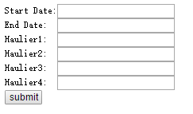

**Users’ inputs are processed by http method ‘GET’ and writer function from csv module in the python script. CSV writerow helps to write the inputs to MMW.csv in one row so that we could easily locate the inputs for later data manipulation.**

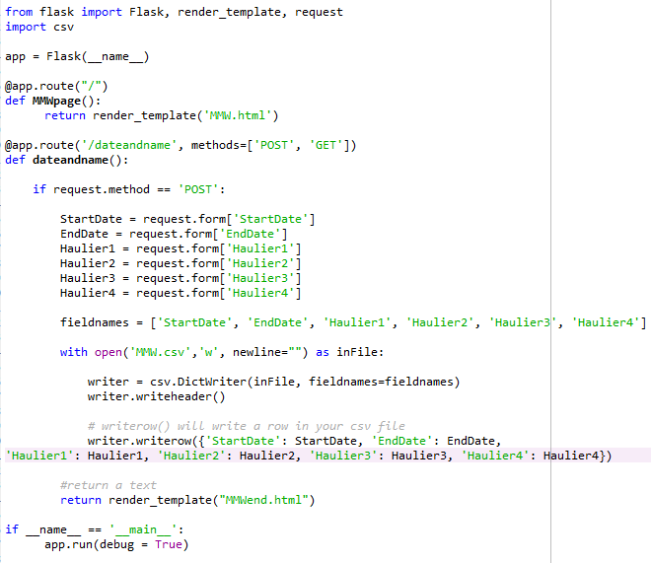

**Executing the MMWChart.py script to access the MMW.csv file to get the hauliers and the time period they want to show and then to generate trending charts for each hauliers.**



**In the first part of MMWChart.py, using Pandas library to read user inputs csv file MMW.csv and copy of super template kpi.csv file. By using df. iloc function locating the certain dates and names of hauliers in template file and read them into Pandas pkl format by for later plotting.**

**In order to plot multiple hauliers in one chart, concat and groupby are used to group the data together. For keeping the charts clear, legend is added to present each hauliers by different colours and the legend is set to automatically adjust its position wherever it suits the best. In the end, plotting the data by plot and save them to statics folder for later use.**

**Problems with the doc and code:**

**Cannot plot the second input haulier.**

**TOF.py**

**Problems with doc and code:**

**If and ot target line will show after the data filled in excel table**

**Axis cannot auto adjust by different range of data each time periods**

**Cannot plot On Time to 1st Hub, %**

**Back-end**

**In input html script, the code can only add 3 of the selected objects to the array sometimes including un wanted ones.**

**Front -end:**

**Design**

**Introduction**

**Simple instruction**

**user Interface:**

**design**

**how it should work**

**problems**

**drop down menu to select**

**output the report to PDF**

**testing**

**method**

**problem**

**cannot render more than one html that generated by Pandas in the report page.**

**outlook and improvement for the application**

**improvement based on current application**

**create another button allow users to add more hauliers and IMC they need.**

**In some circumstance, it would be possible that Yusen uses more than four hauliers sometime. Adding more haulier**

**improving with how the data are stored database, cloud**

**Learning outcomes-reflection-has developed insight and understanding**

**Learning new tool for web application developing, consolidate and apply the knowledge learned through the year to practice. Apply theory of soft engineering developing to this application development.**

**Structure the code as soon as possible**

**instruction for users**

**Supportive tools**

**Anaconda python environment or windows command line, Matplotlib library and Pandas library**

**how to install essential tools**

**install flask**

**install matplotlib**

**install pandas**

**Recommend users to install and run the application via windows command line. Though the anaconda has already had those libraries as package in the its system, the program would perform slower after times of running and even experience some crushes.**

**how to use the application**

**how this application works**

**where they can keep original file and be ready for exacting by the application**

**save all the file in the same folder and create related subfolder for instance under the main KPI folder, creating a statics folder for storing generated charts and template folder for html written report template.**

**important message:**

**month data format**

**float number format**

**blank cell**

**Problems:**

**Flexibility**

**Performance**

**Command line needs to be restarted after 20 times running.**

**Cost**

**Code not flexible. Could choose different time span but cannot choose number of hauliers or IMC.**

**Run at back end cannot run from user interface for now.**